With Best Wishes for Christmas

and the New Year

2018-2019

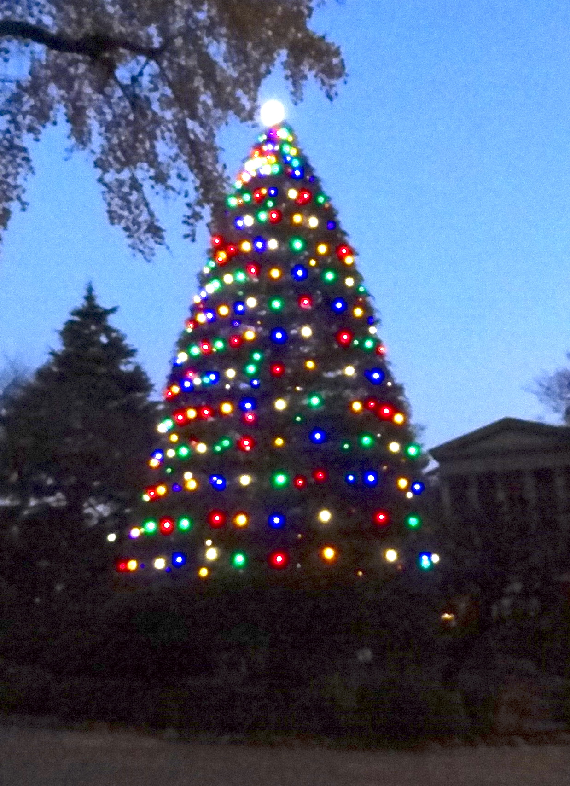

So, another year has passed, and here I am, still going strong and in good health at 92, and I trust you too are keeping fit and well. My movements are limited, as I can only walk around just for short distances in my beautifully sunny room, decorated with family photos and other mementoes, and in the neighbouring corridors, with the aid of my walker. When I want something to do, I can pick a book to read out of my vast hoard of books in big bookcases in my room.

This year has brought its own series of events. Perhaps the biggest was the 99th birthday party of one of my earliest friends here, Adrienne ('Rienne') Wada. She and her family, husband Soichi, children Robby, Johnny and Marianne, were my neighbours in the same compound near Meguro station when I was here as a part-time teacher from 1955 to 1961. Rienne used to include me in their family meal every night.

Although I had imagined that the 99th birthday would be a big one because in the old Japanese way of reckoning you are one year old when you are born so 99 years later you are 100, Prof. Yoshiba has given me another idea. According to him, 99 is one of the festive numeral trios: 77 for *kiju*, 88 for *beiju* and 99 for *hakuju*, and *hakuju* is so called as百 "hundred" minus 一 "one" is 白*haku* "white" in a sort of rebus puzzle with Chinese characters. Also, these are festive numbers by themselves just because Japanese consider *zorome*, a sequence of the same numbers, to be lucky.

Rienne's party was held in the Tokai University Alumni Hall in the Kasumigaseki Building 35F. All her family were there, including grandchildren and great-grandchildren, and I also met many other old friends. Rienne herself is absolutely indestructible, in better shape than I am. My own birthday also was a heart-warming one spent with some of my old students in a little Italian restaurant which we took over completely for the afternoon. I forgot to say last year that it was the 50th anniversary of my arriving here as a fulltime professor at Aoyama Gakuin University in 1967, so it's now 51 years.

One big, but undesirable, event occurred on October 1st, when a typhoon passed right over this building. The balcony outside my room has as 8-inch wall, so the rain water couldn't escape quickly, and it flooded into my room as far as where I was sitting, so I just stayed there while they mopped up. Luckily, my bedroom, with its tatami, was unaffected. But the dining room was completely under water, and we had lunch in a small tearoom; by the evening the water had finally subsided, so we had our supper as usual.

Another anniversary, an international one, which has some significance for me, was the Centenary on November 11th of the Armistice marking the end of WW1. In London a national memorial called the Cenotaph was erected in Whitehall, not far from the Houses of Parliament, and war memorials were built throughout the country, so that you will find in every little village a monument showing the names of all the villagers who died in the war. One notable memorial was erected in my old school, Charterhouse, with all the names of the boys who died engraved in an area just inside the entrance door. This chapel was designed by Sir Giles Gilbert Scott, who built (among other eminent buildings) the New Court of Clare College, Cambridge, which was designed so that through its arch you could see the tower of the jointly designed University Library.

In May Joan had her 90th birthday, and I have a picture of her and her good neighbour Maureen Maguire sitting in the local bistro, with a cake in front of them made specially by the proprietor. Alas, later that month her beloved cat Penny died at the ripe old age of 19. When Joan first got her, she was told that Penny's age was estimated to be 9, so she was a faithful companion for 10 years, sitting next to Joan furing the daytime and lying on her bed at night.

Last month I had a surprise visit by an old student I had not seen for many years. After graduating, she went to England to pursue her studies, and married an Englishman, and they had two supremely intelligent children, a boy and a girl. I used to visit them every summer until 2012, after which I stopped going to England. It was a great joy to see her again.

This year I am celebrating Christmas at Tokyo Union Church on December 25; this is the day on which they have asked me to read the lesson in church.

With warmest greetings,

　　　　Hugh E. Wilkinson

